Report

Patrick Abou Gharib

10137116

----------

Baseline program run time: 9m44s

-----------------------------------

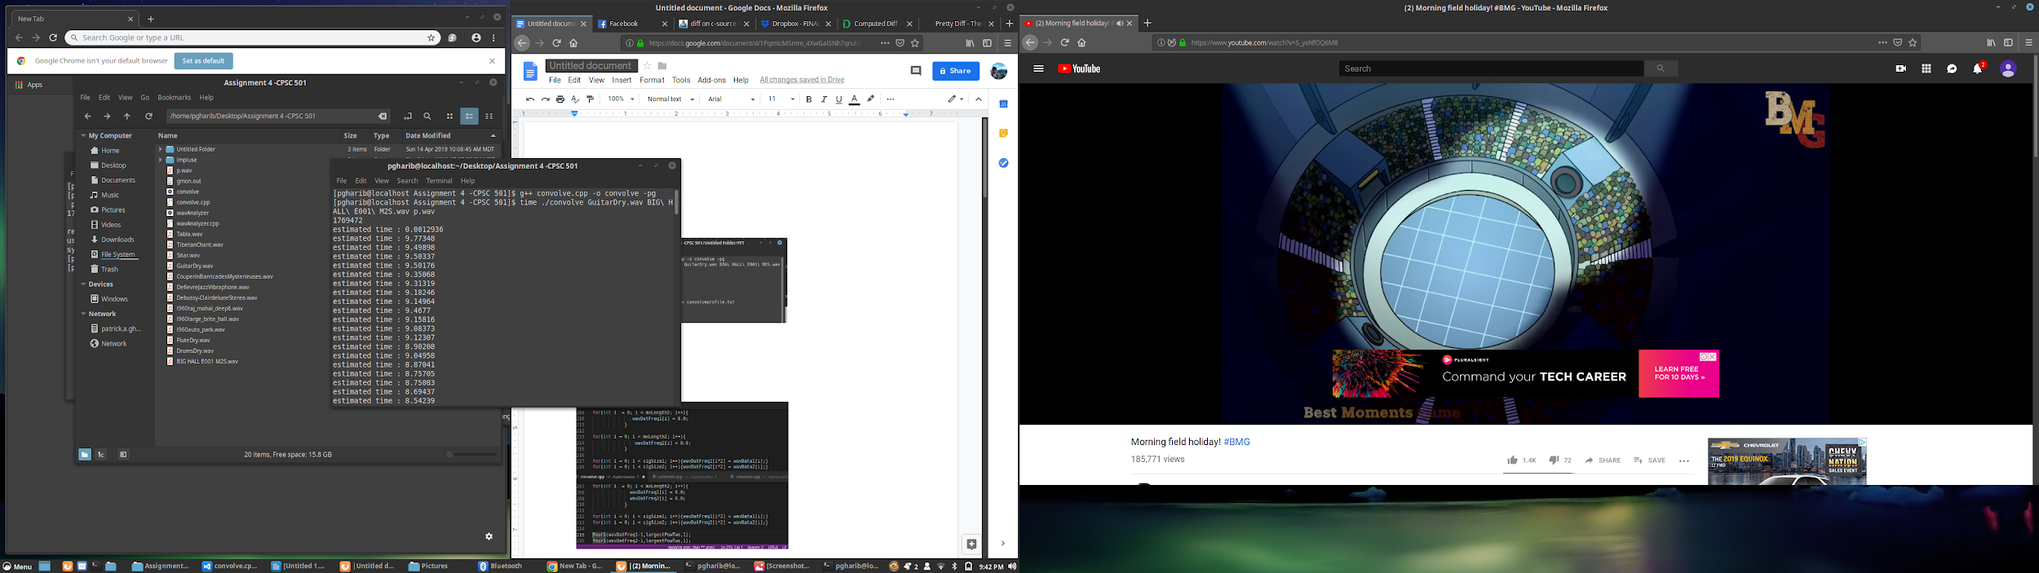

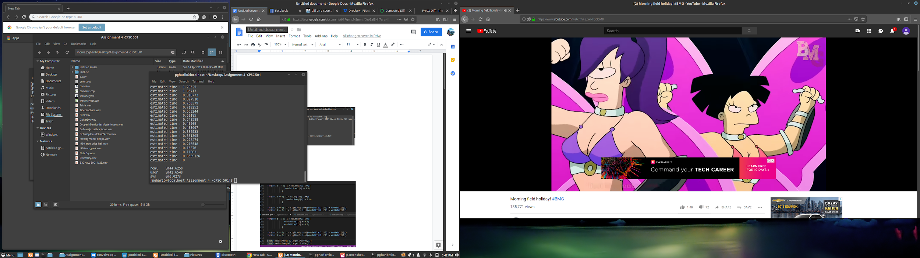

FFT Algorithm based optimization run time: ~4s

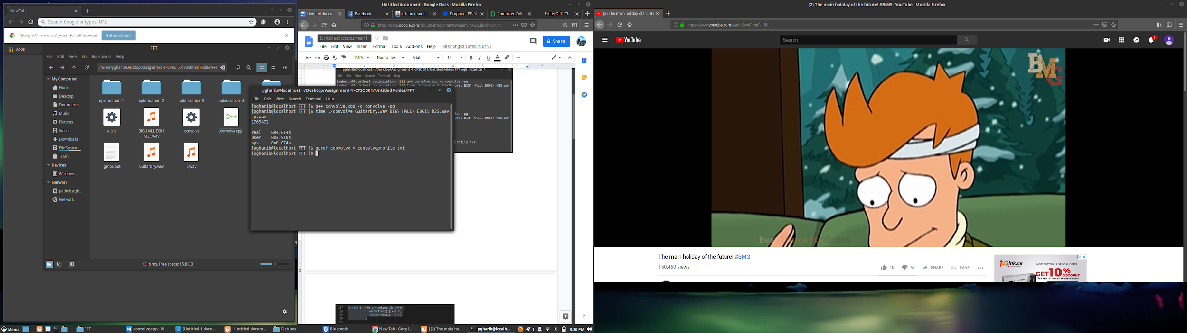

implemented convolutions with frequency domain algorithm.

The improvement in the run time was substantial. The run time improved by 9m41s. This is to be expected since the input side algorithm has an quadratic time complexity whereas the FFT algorithm has a linear time complexity.

1. The first optimization I performed was **code jamming** where merged two loops into 1 in order to reduce the number of iterations performed. Which lead to a performance improvement of roughly 1s.

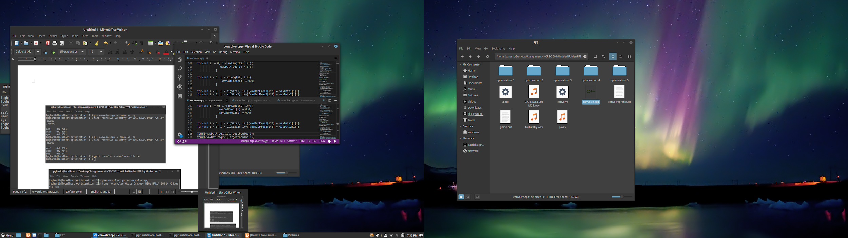



2. After the **code jamming** optimization I **unrolled** the loop to single line instructions. Rather than iterating through the loop I simply modify chunks of memory using memset. This lead to a performance increase of roughly .2 seconds.

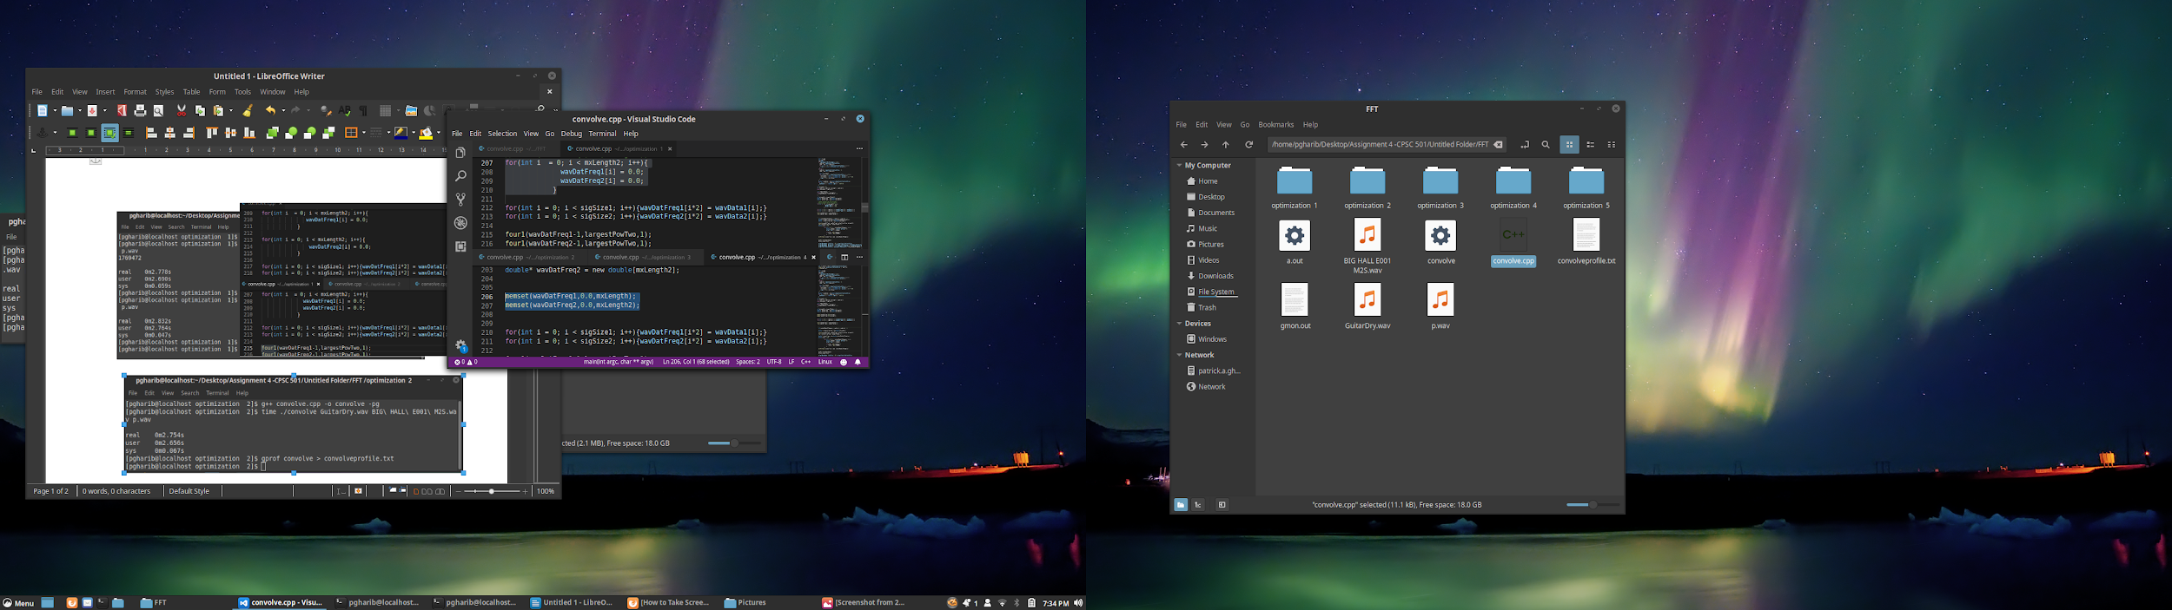

3. After **unrolling** the four loop, I **minimized the the work inside the loop** by moving the division from inside the loop to the outside the loop. That way the calculation will only occur once rather than occurring during each iteration. Again this only lead to a minor improvement in run time ~.1s

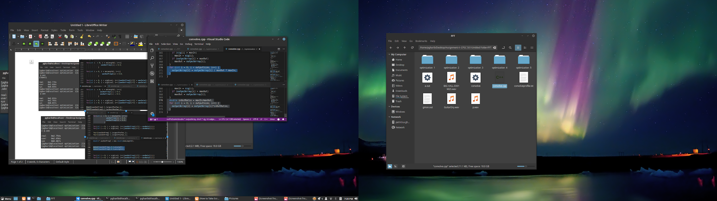

After **minimizing the work in a loop**, I performed a strength reduction. To do this I changed the the multiplication of 2 to a logical shift left which is a less expensive operation. This lead to a minor improvement of ~.01s.

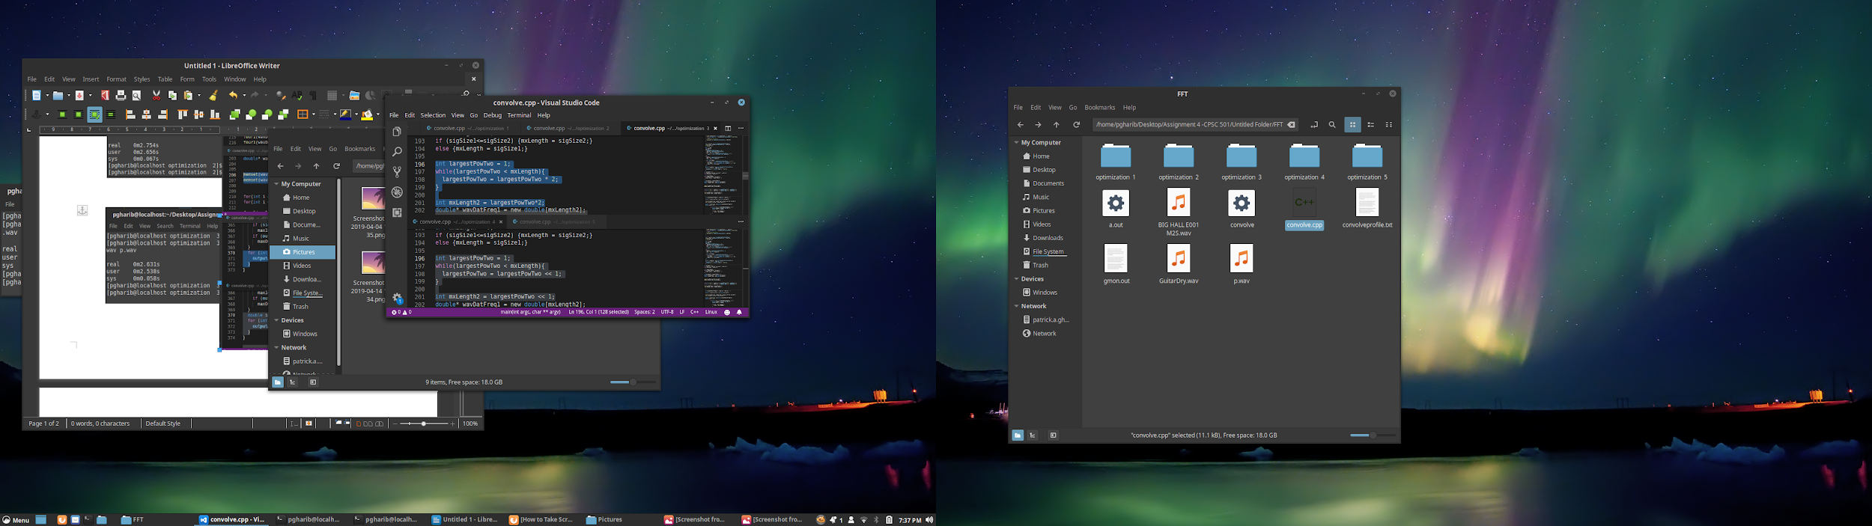

The 5th optimization was minimizing the array references made. This lead to a performance increase of again ~.01s

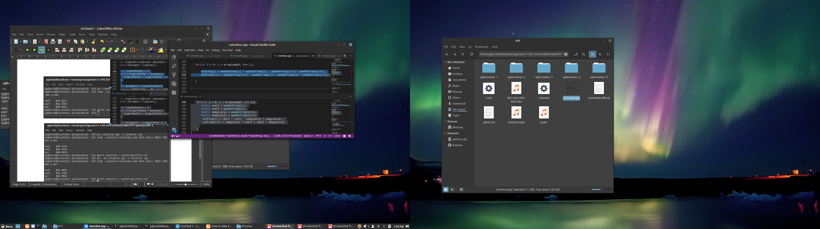

Using the -O3 option during compilation the run time was improved by a full second.



Throughout the optimization process I used the “diff” comparator on the command line for regression testing. Each time the files were equivalent.